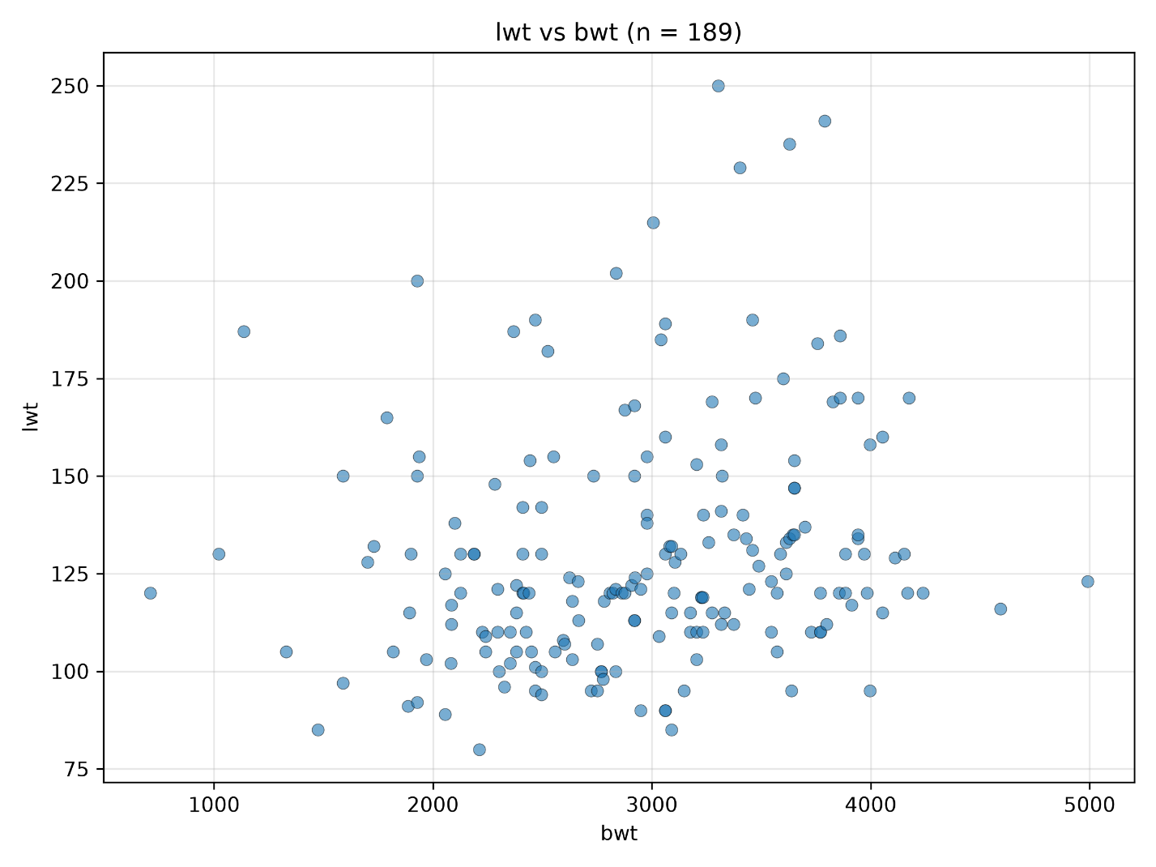

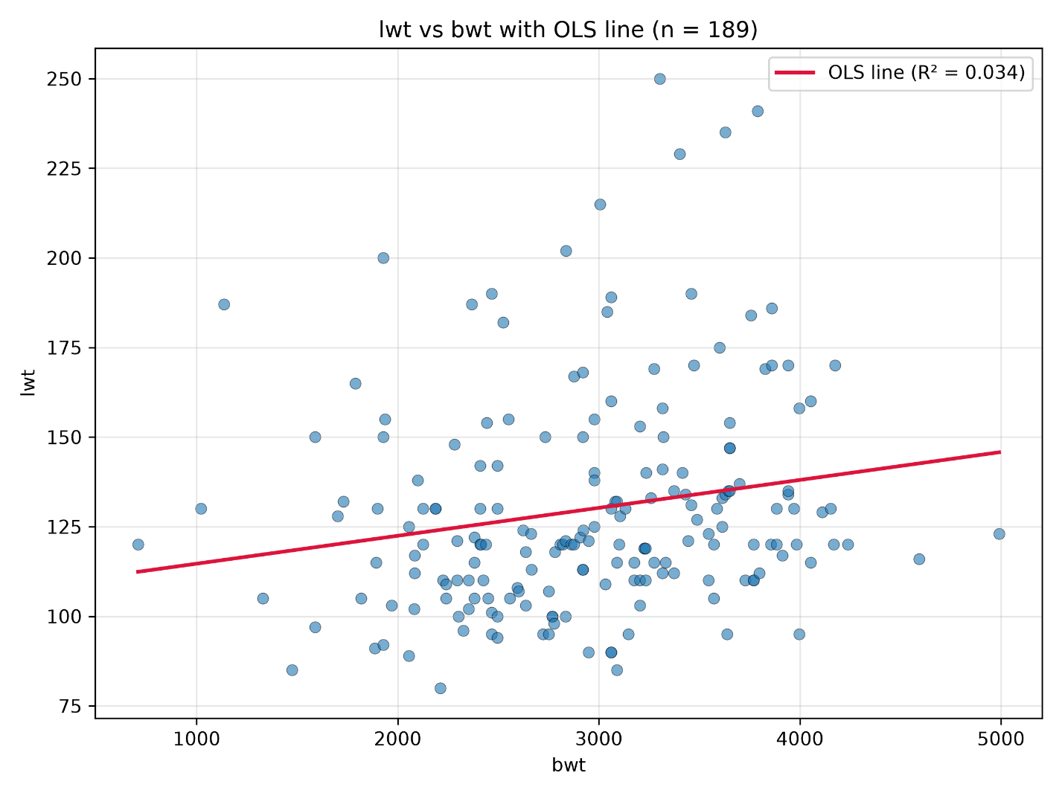
- Name of Independent variable
  - lwt – mother’s weight
- Name of dependent variable
  - bwt - birthweight
- β0 value (intercept)
  - 2369.623517873998
- β1 value (slope coefficient)
  - 4.429107606350708
- R^2 value
  - 0.03449685295225002
- Description
  - There appears to be a very weak positive relationship between mother’s weight and birthweight. For every 1 lb increase in mother’s weight, there is a 4.43 grams expected increase.
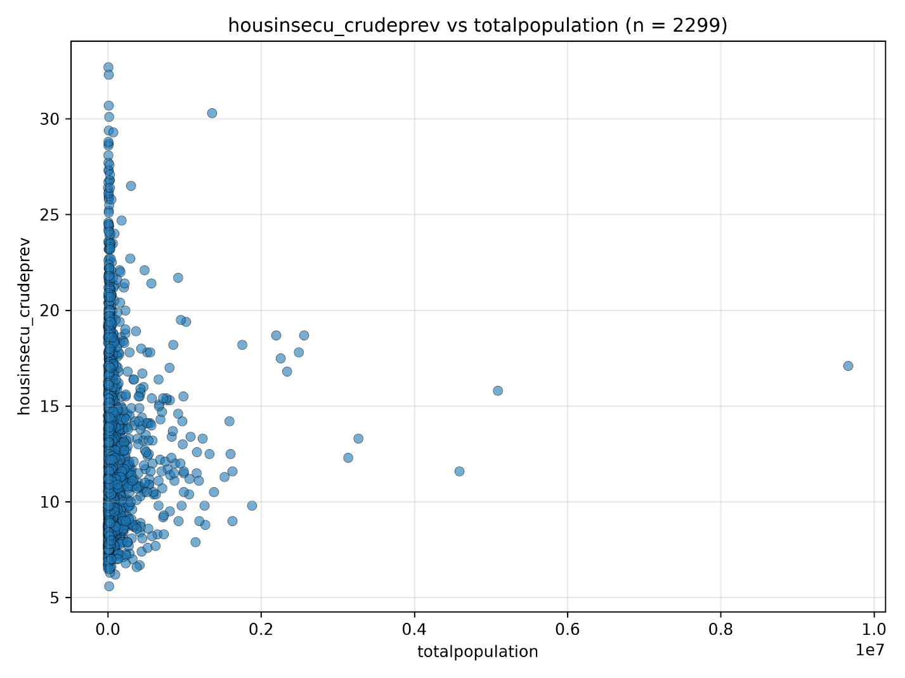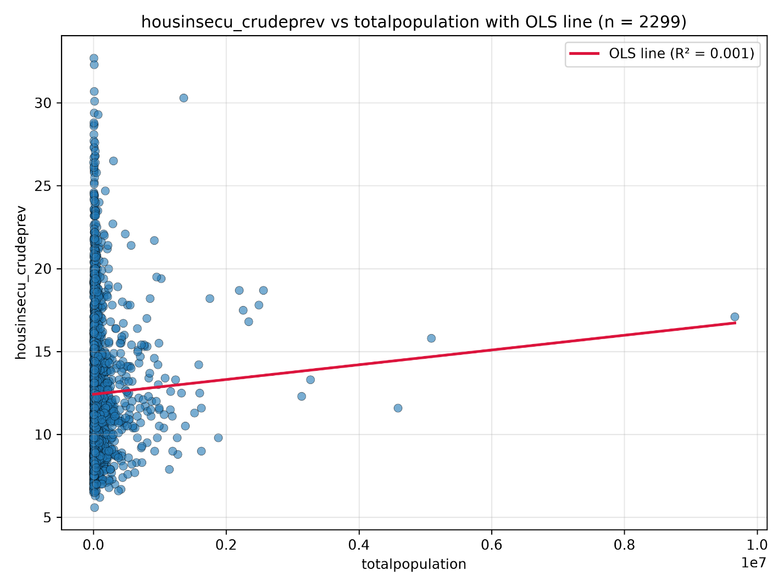

- Name of Independent variable
  - Total population
- Name of dependent variable
  - Housing insecurity, crude prevalence
- β0 value (intercept)
  - 12.41808836528937
- β1 value (slope coefficient)
  - 4.4500030671062605e-07
- R^2 value
  - 0.0013583087056008303
- Description
There appears to be a weak positive relationship between total population and housing insecurity. For every 100,000 person increase in population, there is a 0.045% expected increase in housing insecurity.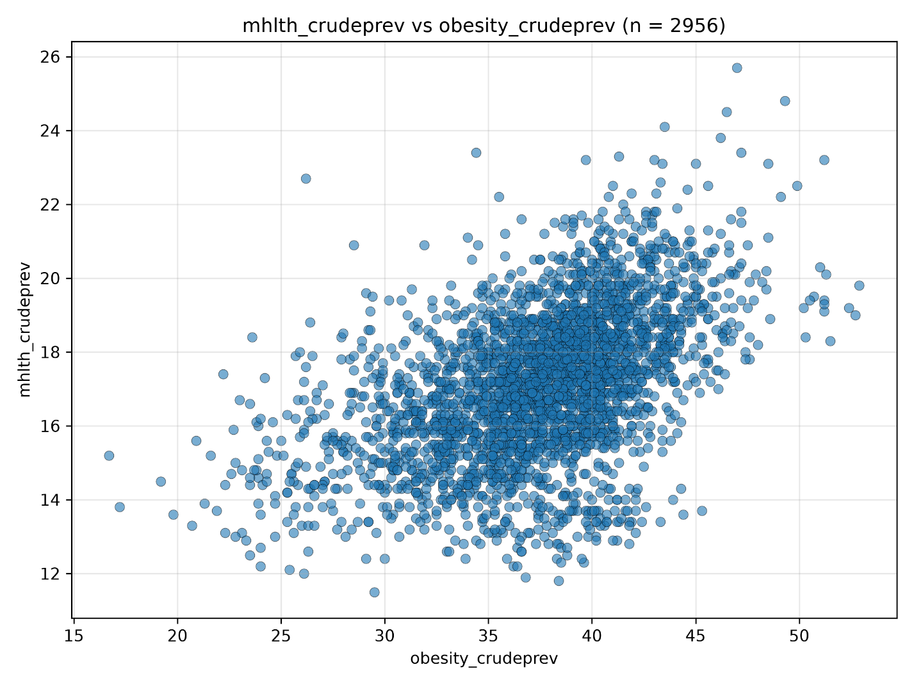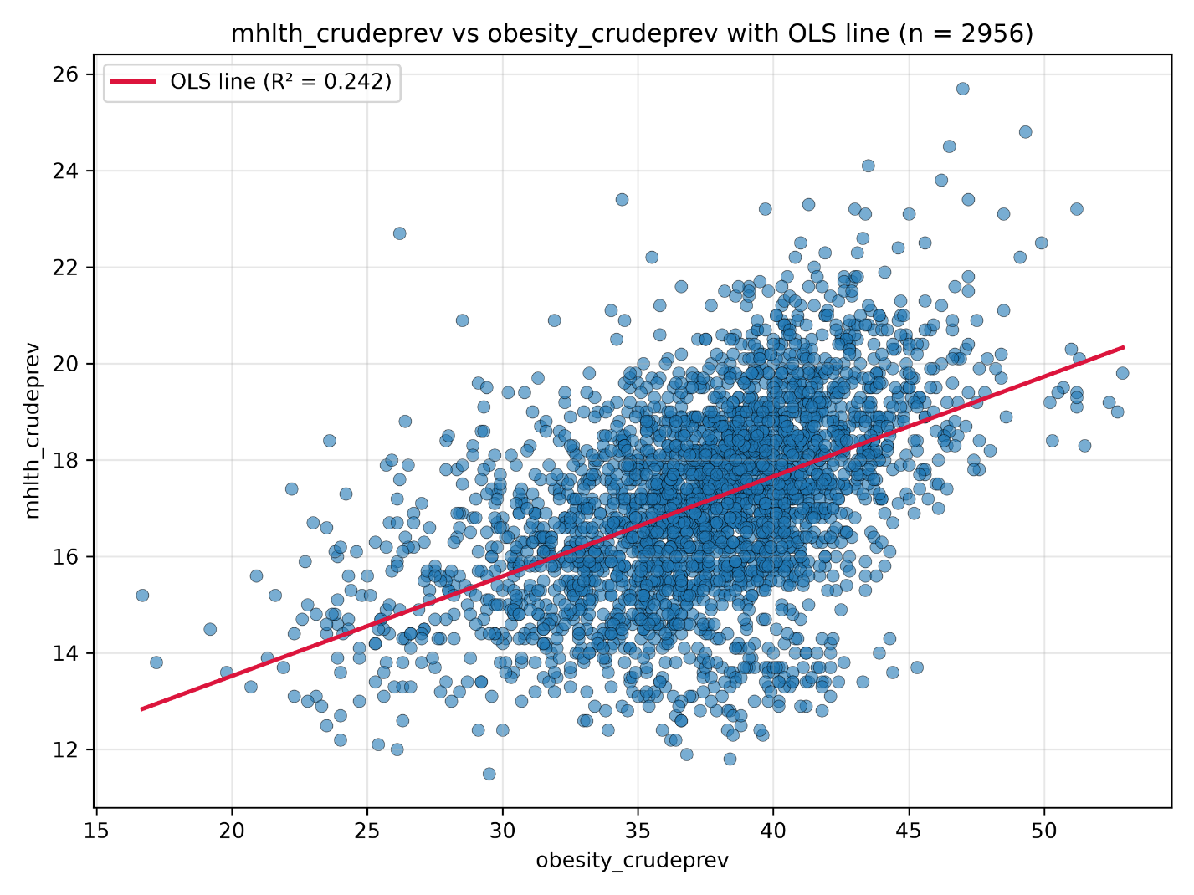

- Name of Independent variable
  - Obesity, crude prevalence
- Name of dependent variable
  - Frequent mental health distress in adults, crude prevalence
- β0 value (intercept)
  - 9.382995902232345
- β1 value (slope coefficient)
  - 0.20687228801732332
- R^2 value
  - 0.2417627696734439
- Description
  - There appears to be a weak-to-moderate positive relationship between obesity prevalence and prevalence of frequent mental distress in adults. For every 1% increase in obesity prevalence, there is a 0.21% expected increase in the prevalence of frequent mental distress in adults.

